# Day:-24/08/24

**Sequence Diagram:-**

@startuml

actor Student

actor Teacher

participant "AssignmentManager" as AM

participant "ChatModule" as CM

participant "PersonalAITutor" as PAT

participant "VisualizationComponent" as VC

participant "NotificationSystem" as NS

participant "ResourceManager" as RM

== Student: Managing Assignments ==

Student -> AM: Upload Assignment

AM --> Student: Confirm Upload

Student -> AM: Submit Assignment

AM --> Student: Confirm Submission

Student -> AM: Delete Assignment

AM --> Student: Confirm Deletion

Student -> AM: Check Assignment Status

AM --> Student: Display Assignment Status

Student -> AM: Check Assignment Score

AM --> Student: Display Assignment Score

== Student: Chat ==

Student -> CM: Chat with Friends

CM --> Student: Display Friend's Reply

Student -> CM: Chat with Professor

CM -> Teacher: Notify Professor

Teacher -> CM: Reply to Student

CM --> Student: Display Professor's Reply

== Student: Personal AI Tutor ==

Student -> PAT: Request Tutoring Session

PAT --> Student: Provide Tutoring Session

== Student: Visual Elements ==

Student -> VC: View Assignment Scores

VC --> Student: Display Scores Graph

Student -> VC: View Deadlines

VC --> Student: Display Deadlines

Student -> VC: View All Assignments

VC --> Student: Display Assignments

Student -> VC: Add Sticky Note

VC --> Student: Confirm Sticky Note Added

== Student: Notifications ==

Student -> NS: View Notifications

NS --> Student: Display Notifications

== Student: Resources ==

Student -> RM: View Resource

RM --> Student: Display Resource

Student -> RM: Download Resource

RM --> Student: Confirm Download

== Teacher: Managing Assignments ==

Teacher -> AM: Upload Assignment Question

AM --> Teacher: Confirm Upload

Teacher -> AM: Delete Assignment Question

AM --> Teacher: Confirm Deletion

Teacher -> AM: Post Assignment

AM --> Teacher: Confirm Post

Teacher -> AM: Check Student Assignment

AM --> Teacher: Display Assignment

Teacher -> AM: Score Assignment

AM --> Teacher: Confirm Score Submission

== Teacher: Chat ==

Teacher -> CM: Chat with Student

CM -> Student: Notify Student

Student -> CM: Reply to Teacher

CM --> Teacher: Display Student's Reply

== Teacher: Notifications ==

Teacher -> NS: Send Notification

NS --> Teacher: Confirm Notification Sent

== Teacher: Resources ==

Teacher -> RM: Upload Resource

RM --> Teacher: Confirm Upload

Teacher -> RM: Delete Resource

RM --> Teacher: Confirm Deletion

Teacher -> RM: Provide YouTube Link

RM --> Teacher: Confirm Link Provided

== Teacher: Visualization ==

Teacher -> VC: Visualize Student Performance

VC --> Teacher: Display Performance Graph

@enduml

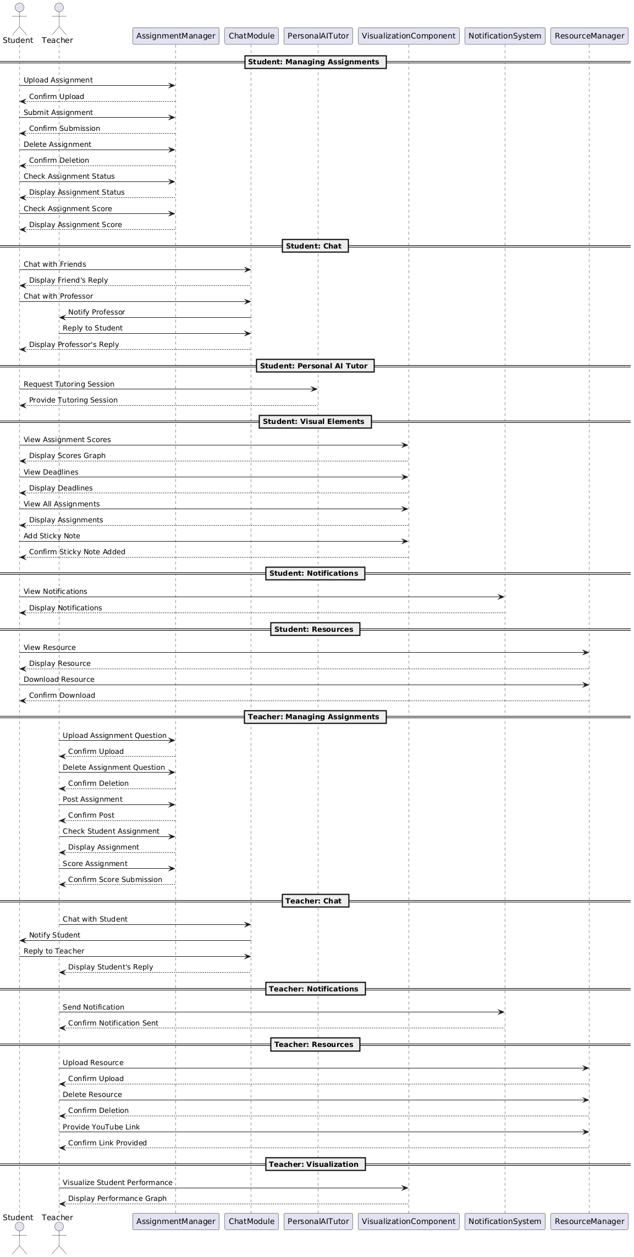

**Class diagram:-**

@startuml

class Teacher {

+uploadAssignmentQuestion(document: String)

+deleteAssignmentQuestion(assignmentId: int)

+postAssignment(assignmentId: int)

+checkStudentAssignment(studentId: int, assignmentId: int)

+scoreAssignment(studentId: int, assignmentId: int, score: int)

+chatWithStudent(studentId: int)

+sendNotification(notification: String)

+uploadResource(resource: String)

+deleteResource(resourceId: int)

+provideYouTubeLink(link: String)

+visualizeStudentPerformance(studentId: int)

}

class Student {

+uploadAssignment(assignmentId: int, document: String)

+submitAssignment(assignmentId: int)

+deleteAssignment(assignmentId: int)

+viewAssignment(assignmentId: int)

+checkScore(assignmentId: int)

+chatWithPeers(friendId: int)

+chatWithProfessor(professorId: int)

+usePersonalTutor()

+viewCharts()

+Notes(note: String)

+viewNotifications()

+checkResources()

+downloadResource(resourceId: int)

}

class Assignment {

+assignmentId: int

+questionDocument: String

+submitAssignment(studentId: int)

+viewAssignment()

+deleteAssignment(assignmentId:int)

+scoreAssignment(score: int)

}

class Chat {

+chatId: int

+studentId: int

+sendMessage(message: String)

+receiveMessage(): String

}

class Notification {

+notificationId: int

+message: String

+sendNotification()

}

class Resource {

+resourceId: int

+document: String

+youtubeLink: String

+uploadResource()

+deleteResource()

+viewResource()

+downloadResource()

}

class PerformanceVisualization {

+studentId: int

+generateGraph()

}

class PersonalAITutor {

+query: String

+helper()

}

Teacher --> Assignment : Manages

Teacher --> Chat : Communicates

Teacher --> Notification : Sends

Teacher --> Resource : Manages

Teacher --> PerformanceVisualization : Visualizes

Student --> Assignment : Manages

Student --> Chat : Communicates

Student --> Notification : Receives

Student --> Resource : Accesses

Student --> PerformanceVisualization : Views

Student --> PersonalAITutor : Uses

@enduml

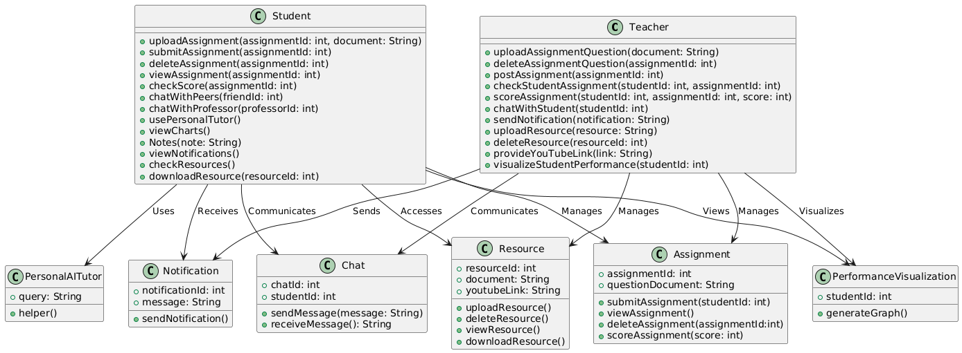

**Component Diagram:-**

@startuml

left to right direction

package "Components" {

[Student Service] as StudentService

[Teacher Service] as TeacherService

[Assignment Service] as AssignmentService

[Chat Service] as ChatService

[Notification Service] as NotificationService

[Resource Management Service] as ResourceService

[Visualization Service] as VisualizationService

[Personal AI Tutor] as AITutorService

}

package "Frontend Components" {

[Student UI] as StudentUI

[Teacher UI] as TeacherUI

}

StudentUI --> StudentService : Interacts with

TeacherUI --> TeacherService : Interacts with

StudentService --> AssignmentService : Manages Assignments

StudentService --> ChatService : Chats with Peers and Teachers

StudentService --> NotificationService : Receives Notifications

StudentService --> ResourceService : Accesses Resources

StudentService --> AITutorService : Uses AI Tutor

StudentService --> VisualizationService : Views Performance Visualization

TeacherService --> AssignmentService : Manages Assignments

TeacherService --> ChatService : Chats with Students

TeacherService --> NotificationService : Sends Notifications

TeacherService --> ResourceService : Manages Resources

TeacherService --> VisualizationService : Visualizes Student Performance

AssignmentService --> Database : Stores Assignment Data

ChatService --> Database : Stores Chat Data

NotificationService --> Database : Stores Notification Data

ResourceService --> Database : Stores Resource Data

VisualizationService --> Database : Stores Performance Data

@enduml

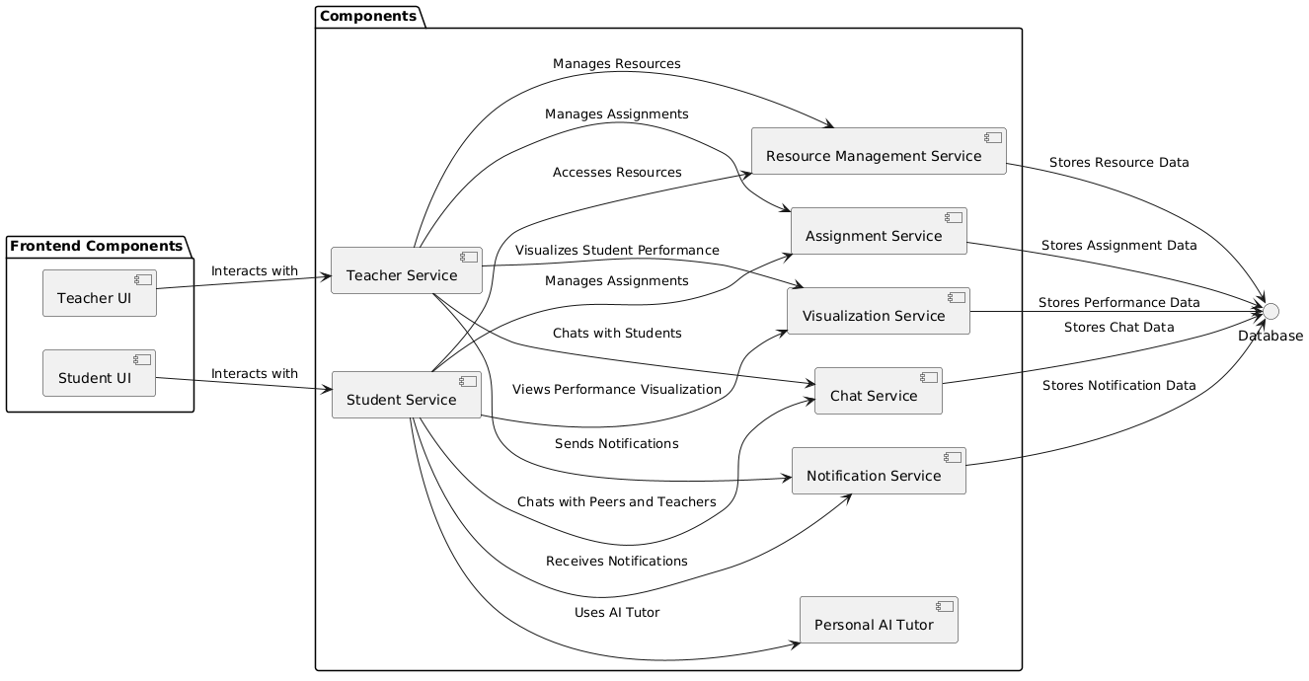

**Database Diagram: -**

@startuml

entity Student {

student_id : PK

name : String

email : String

password : String

course_id : FK

assignment_id : FK

}

entity Teacher {

teacher_id : PK

name : String

email : String

password : String

course_id : FK

}

entity Course {

course_id : PK

course_name : String

teacher_id : FK

}

entity Assignment {

assignment_id : PK

course_id : FK

assignment_name : String

assignment_description : Text

due_date : Date

}

entity Submission {

submission_id : PK

assignment_id : FK

student_id : FK

submission_date : Date

grade : String

}

entity Resource {

resource_id : PK

course_id : FK

resource_name : String

resource_link : String

}

entity Chat {

chat_id : PK

sender_id : FK

receiver_id : FK

message : Text

timestamp : DateTime

}

Student ||--o{ Course : "enrolls in"

Teacher ||--o{ Course : "teaches"

Course ||--o{ Assignment : "has"

Student ||--o{ Submission : "submits"

Assignment ||--o{ Submission : "receives"

Course ||--o{ Resource : "provides"

Student ||--o{ Chat : "sends/receives"

Teacher ||--o{ Chat : "sends/receives"

@enduml

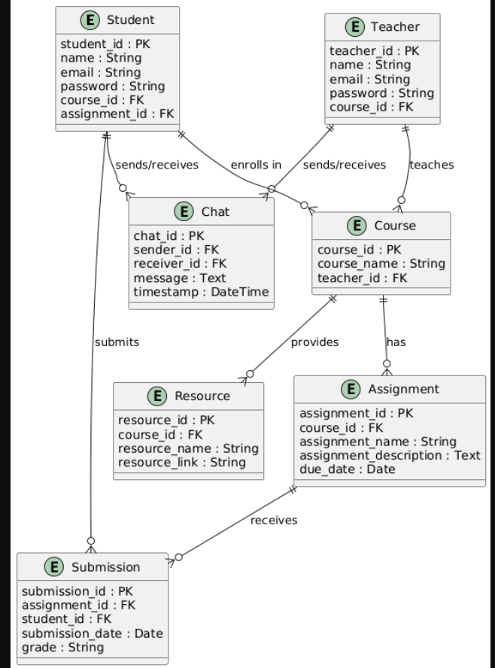

# Day:-26/08/24

**Class Diagram(For above microservices):-**

@startuml

class Course {

+getAllCourses()

+getRecentCourses()

+getEachAssignmentScore()

}

class Assignments {

+uploadAssignment()

+displayAssignment()

+deleteAssignment()

+getDeadline()

+getScore()

+getSubmissionStatus()

+filesSubmitted()

}

class Chat {

+sendMessage()

+receiveMessage()

}

class PersonalAiTutor {

+sendQuery()

+queryResult()

class ProfilePage {

+getStudentDetails()

+getCourseDetails()

+getTotalOfEachCourse()

}

class Notification {

+sendNotifications()

+showNotifications()

}

class Resources {

+viewResources()

}

class Student

Student --> Course : interacts

Student --> Assignments : interacts

Student --> Chat : interacts

Student --> PersonalAiTutor : interacts

Student --> ProfilePage : interacts

Student --> Notification : interacts

Student --> Resources : interacts

@enduml



